Title: Software Time Estimation: Are We There Yet?
Author: Jack Fuller
Article Summary:
This research paper by Jack Fuller is trying to explain what exactly estimate means. The failure or success of a project is assessed based on the developer’s capabilities or line of code, but that’s not always the case. We need to examine whether we were able to complete the entire functionality not the basis of time estimates not on the lines of code. In introduction part author explained the meaning of estimate and several other terms such as task, target, and commitment which plays an important role while calculating estimates. Estimates can be rough ones or fair ones, but it is better to have estimate rather than have nothing. This study reveals out the factors which an individual or developers need to know before they prepare estimates for a project. This helping removing errors in estimating time and make project a success rather than cancelling or delaying them. Jack Fuller proposed concept of time estimation for building software and essential techniques to be used for making realistic estimates rather than having over or under estimates and screw up entire project. Estimates helps in keeping track on how to go ahead in the project and what are the factors to keep in mind so as they do not impact success of project. Author carried out this research in accordance with cone of uncertainty and mentioned tips to be followed to avoid failures. Some of the techniques such as work breakdown structure and project evaluation and review techniques(PERT) are introduced and detailed to increase the project accomplishment. This article is written based on experience of author working as an SAS Engineer, so I targets the audience who are currently in the industry facing issues in having appropriate planning, time management issues, decreasing success rate for a project. Following some of the techniques will surely help in improving standards for estimations and at least they will be realistic but not accurate.

Article Analysis:
The author styled out an important concept for professional and even students to understand as everyone be a developer/ tester or manager are asked to give estimates for completion of task. Appropriate level of details are laid out in the study starting from the basic terms definition to their use in determining the estimates and schedule of a project. Target refers to the goals or objective which needs to be accomplished after the project is done. Commitment is defined as the features or product capabilities to meet within time frame. Most importantly the term estimate is the time and cost/money required to fulfill the entire project with deliverables promised.
It is essential for team members to understand actual requirement, clients expectation from them to achieve target. It is mostly seen that estimates are reduced to achieve target which is incorrect in a project. It is not good to sacrifice on estimates. There should be common understanding on terminology, what exactly estimate refer to. Several team members understand it in some other sense. All should be at same platform. If there is scope of confusion or inconsistencies, then it needs to be clarified.
Fuller explained various estimates curves derived by McConell regarding single point estimate which are bad and should not be used. Bell shaped curves also proves inaccurate. Below curve seems to be accurate as there is always a periphery on how much we are able to achieve but some risk and uncertainties are always there. Main objective of estimate is can we go ahead with the project or are we able to control the project at any point of time. Need to analyze several factors such as team competencies, time required, dependencies, constraints, feasibility analysis, getting correct requirement and understand stakeholder’s vision.
Sometimes in project it is difficult to estimate everything at once and also something’s are unpredictable. Therefore author relates it to cone of uncertainty stating that in preliminary stages of software development requirements, resources, planning, are pretty tough or unclear resulting in variations in the estimates to be accurate. But as we proceed on the other stages, things are clear, greater understanding that narrows down the gap and estimates become stable.
Work Breakdown structure technique suggested by writer says we can split up on the features and capabilities or task required, make a list which will help in organizing, completion of stuff and achieve those efficiently. We can also divide all stages in phases and achieve chunks of functionality in every phase. PERT creates Worst Case (W), Likely case(L), Best Case(B) for each task and then based on calculations they are put into curve shown below:
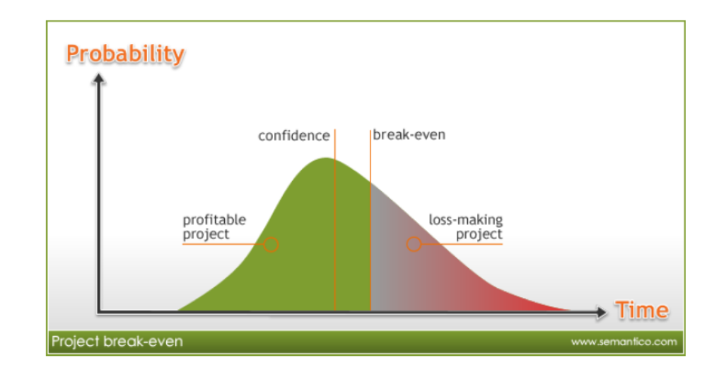

Article Critique:
This study of Software time estimation provides in-depth information of estimates. Based on my reading of this paper below are the strengths and weakness:
Strengths:
- Reader gets a thorough understanding of estimate approach and how it can prove useful for professionals to use in their practical life.
- It is very important for all members of team to be in the same boat for making estimates, should have clear understanding of terms when they are referred by project managers for laying out estimates. Team member should raise queries if any concern related to estimates.
- It should always be noted that all projects are different, making assumptions based on previous project failure or success, and over estimating or under estimating them is a big mistake which takes place in industry.
- This paper goes well with the title as author detailed estimate and techniques to be used.
- I liked the example given by author related to estimating some task is difficult. Such as “how long it will take to put your kids to bed?” You cannot answer this question until n unless you knew their entire day schedule and some knowledge of them. This makes us understand the concept clearly and easy language.
Weakness:
- This does not included or contributed anything new to the industry of software engineers. It is based on author working and professional experience. These approach should first have been tried in some of the projects to prove their authenticity.
- Author should have felt the need to include more details along with the diagrams and the graphs he used. One simple line example does not justify the research paper analysis and study for readers.
- Many of the diagram and tips are taken from Steve McConnell, I believe author should have given credit or acknowledgment to him in the end.
- His paper will not catch attention of highly experienced technocrats as it includes personal experience and not proven in the industry rather it is for beginners so that they become familiar with the terms and concepts and could us them initially when new in the market.

